**Midland Zone of PCV**

**Pony Club Individual & Team Show Jumping &**

**Team of Four/Pairs Flat Ride Shield**

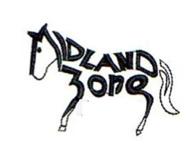**A0002713N**

**OPEN SECTION FOR SHOW JUMPING EVENTS**

**SUNDAY 17th AUGUST 2025**

To be held at Horsham Pony Club

Riverside Recreation Reserve, Petrie Lane, Horsham

*Hosted by Section A/B- Ararat, Beaufort, Charlton, Donald, Horsham, Learmonth, Loddon, Stawell*

**FLAT RIDE SHIELD**

* Pairs
* Team of 4

**ENTRY FEE:**

$40.00 per team of 4.

$20 per pair

**TEST:**

Test 1 – available of Midland Zone website “Forms” page.

**SHOWJUMPING**

Grades A, B, C, D, E, F, G

Pony Club & Open Classes

(Adult PC riders must enter open section)

**ENTRY FEE**

PC members - $15 per event (+ $10 per rider entering a team)

OPEN (non-PC members) $20 per event.

**Event 1:** AM7 (Article 245.3)

**Event 2:** Table C (Article 239)

**ENTRIES:** https://eventsecretary.com.au/equestrian/

**ENTRIES CLOSE: Sunday 10th August 2025**

**Full Canteen Facilities including breakfast.**

Camping - $10 per vehicle (limited powered sites)

Horse yards - $10 per yard.

Please leave yards clean **MUST** be Booked through [horshampcvic@gmail.com](mailto:horshampcvic@gmail.com) 0409256585

**Signup will be used for job allocation for this Zone Event.**

**Events cannot run without volunteers.**

**Each competitor is required to help/ provide a helper**



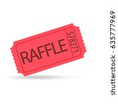

Raffle to be run on day.

**Riders may compete in BOTH Showjumping and the Flat ride.**

**Riders may ride more than one horse on the day.**

**Each Team can have a maximum of ONE Adult PC Rider.**

**Midland Zone Flat Shield Event**

**Team of Four Flat Ride & Pairs**

No height restriction for horses. If a club enters more than one team, please give each team a name or letter for easy identification.

Teams to supply own back numbers 1-4 or 1-2.

Max. 1 adult PC member per team.

**PLAITING OPTIONAL**

Sashes awarded to sixth place.

**Entry Fee:**

$40.00 per team of 4.

$20 per pair

**TESTS**

Rides were emailed to all members & available on the zone website under “forms”. 2025 is Test 1.

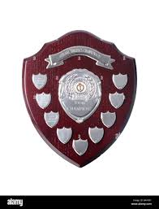

**Zone Shield Show Jumping Competition:**

Grades A, B, C, D ,E, F, G

Pony Club & Open Classes

Individual and Teams

Adult PC members must enter open section.

**PRIZES**

Individuals: PC Sashes awarded to sixth place. Open to 4th place.

Teams: Sashes to 6th place.

**Entry Fee:**

PC members - $15 per event (+ $10 per rider entering a team)

OPEN (non PC members) $20 per event.

**Event 1:** AM7 (Article 245.3)

**Event 2:** Table C (Article 239)

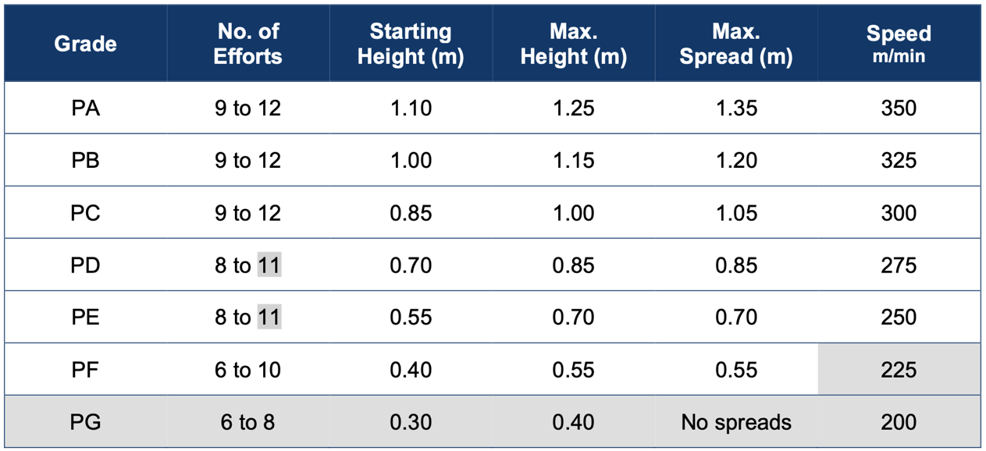

**Team Show Jumping Competition**

* Teams may consist of three to five riders from a Midland Zone Club.
* 1 Adult PC Rider per team.
* Teams may be made up of riders from the same or different grades
* Scoring: see end of program.

**Composite Teams.**

Riders who are unable to make a team from their club can be placed in a Composite Team. Composite Teams are eligible for sashes awarded to sixth place but cannot win the Zone Shield. Riders need to nominate and pay a team fee for a composite team. Money will be refunded if a rider is not able to be placed in a composite team. The Zone will allocate riders to composite teams.

**Event 1:    AM7 (Article 245.3)**

One round with immediate jump off. If rider is clear, (including no time faults) he/she must stay in the ring and wait for a second bell to start their jump off.

**Event 2:**  **Table C (Article 239)**

Faults in this Class are penalized in seconds. If a rail is knocked down, 4 seconds are added to the final time of the round. If there is a disobedience there is no penalty only time wasted. 3 disobediences is still elimination.

For more details on Show Jump events refer to:

**PCV Show Jumping Rules** <https://ponyclubvic.org.au/wp-content/uploads/2025/03/PCV-Showjumping-Rules-2025.pdf>

**FEI jumping Rules -https://inside.fei.org/sites/default/files/Jumping_Rules_2025_clean.pdf**

**SHOWJUMPING SCORING**

**Individual - Points System**

• The number of riders starting in the first class will determine the point allocations for the subsequent classes. E.g. if 22 riders start in the first class, the scoring system for the subsequent classes are based on 22 riders. If only 20 riders start the second class, the scoring system remains at 22 and so on.

• The winner of each class will be awarded points equal to the number of riders in the first class plus 1 point. E.g. 22 starters + I = 23 points. Every rider that completes a class will score points according to their placing in the field.

1st place = 23 points (22+1)

2nd place = 21 points (22-1)

3rd place = 20 points

22nd place = 1 point

• If a rider is eliminated in a class, they will not be awarded points for that class. However, they are eligible to score points in the other classes.

• These individual rider points for each class are added together progressively throughout the day to determine the overall individual award.

• The rider with the highest points is the winner.

• If the Scores are tied, equals will be separated using the best result in the Competition over two rounds. In 2023 this will be Class 1.

**Show Jumping – Team**

• **Regardless of placings in the individual classes, team points are only awarded to riders entered in a team.** Riders not entered in a team are removed from the team scoring pool. E.g., If a rider placed 3rd in a class but is the highest scoring rider entered in a team, they will be awarded the highest points.

• Teams may consist of 3- 5 riders with the best three scores determined as per the individual points system to count.

• In order to be eligible for a team placing at least three members of the Team must complete each scheduled class without elimination.

• At least three Team Members must compete in a Class for the Team to post a score in that class.

• Points obtained by the three highest placed riders in each Team for each class are totalled for that class.

• In the case of equality of points for the final placing, the higher placed team is the one whose lowest classified competitor of the three has the best result in the nominated class. In 2023 this will be Class 1.

**Conditions of Entry:**

1. **Entering this competition constitutes acknowledgement that current PCV rules apply and acceptance of these rules.**
2. **The organizing committee** reserves the right to cancel any class or competition; divide any class; alter times; refuse any entry with or without stating the reason.
3. **Refunds**: No refunds after closing date except with vet or medical certificate. These must be submitted to the Event secretary no later than 7 days after the event.
4. **PCV club member cards:** PCV membership cards must be inspected at the office before riding, on the day of the competition/activity on penalty of elimination. In accordance with PCV Bylaw 15.7.a .ii Grading must not be corrected or altered at a competition.
5. **PCV Gear Check rules must be adhered to.** Required for all riders before competing as per the current PCA Gear Rules. The responsibility to ride in the correct competition gear remains with the competitor. If any judge or official discovers a competitor riding with incorrect competition gear, elimination may occur.
6. **No Dogs Allowed**.
7. Neither the organizing committee of this competition nor the PCV accepts any responsibility whatsoever for any accident, damage, injury or illness to horses, riders, ground spectators or any other person or property.
8. All Non-Pony Club members, and any Pony Club member who cannot show their Pony Club card or prove Pony Club membership must complete the day participant waiver and liability declaration: **Non-Pony Club members** and **PCA/PCV members** who **cannot prove their PCA/PCV membership** must pay **$20 per day** of participation unless exempt by way of holding insurance (as per Page 4 -Liability Declaration) with an equine organization or hold their own insurance. PLEASE BRING THE COMPLETED FORM WITH YOU ON THE DAY. If we need to supply a form for you the cost will be $5 The form is available here: [https://www.ponyclubvic.org.au/wp-content/uploads/2022/03/PCA-GOW-GATES DAY-PARTICIPANT-INFO-DECLARATION-FORM.pdf](https://www.ponyclubvic.org.au/wp-content/uploads/2022/03/PCA-GOW-GATES%20DAY-PARTICIPANT-INFO-DECLARATION-FORM.pdf)
9. No stallions, colts or rigs.
10. PCV Alcohol and Smoking Policies apply.
11. **Lungeing**: is permitted in the round yard only.
12. Queries & protests, horse abuse and doping rules as per the current *PCV Handbook of Bylaws*.
13. Horses/ponies must be at least 4 years old on the day of the competition.
14. **Complying helmets must be worn.** Australia New Zealand standard AS/NZS 3838 Marked SAI Global Australia New Zealand standard, ARB HS 2012 (racing helmets) Marked SAI Global , American standard, ASTM F1163 Marked SEI or SNELL E2001 , British standard ,PAS 015 (1998 or 2011) BSI Kitemarked , European standard VG01.040 (2014-12) may be abbreviated as ‘VG1’ on the helmet label, EN1384 standard plus the VG1 standard
15. **Competitors may ride more than one horse** competitively subject to ballot of entries.
16. All PC & **Open Classes** are subject to entry numbers and **classes may be combined.**
17. saddle cloth numbers. Bridle & saddle cloth numbers must be worn on both sides of the horse. Each flat team is responsible for providing their own back numbers 1-4 & 1,2 (pairs).
18. Presentations: will occur after all equipment has been packed up.
19. Riders who do not stay for presentation MUST arrange for someone else to collect ribbons. These will not be posted out.

**Pony Club Cards** - Any pony club member who does not present an accurate card will be disqualified. It is your responsibility to ensure that your membership card is accurate and presented to the organizing committee on the day, prior to riding.

**Note:** that DC’s may not alter or correct grading at the competition.

If you are not sure about how a membership card must be completed, please read the Membership Cards Guidelines in the ‘publications, rules and regulations’ section of the PCV web site [www.ponyclubvic.org.au](http://www.ponyclubvic.org.au)